Automated Libs analysis with database

# Operation of the Python function

1_Install Anaconda Python 3.6 from this link: <https://www.anaconda.com/download/>

This installs both Jupyter Notebook and Python

2_Copy the file “***LIBS_LIB.py****”* (source code) in the below location:

**C:\ProgramData\Anaconda3\Lib\site-packages**

“***LIBS_LIB.py****”* file can be found in:

**\\ipmlan\PK\Projekte\Fraunhofer\600610_InlineElement\10_akt_Arbeiten_Mitarbeiter\Alireza\Python libs library**

This should be repeated if the source code inside this file is updated.

3_Open Jupyter Notebook

4_Open the file “**LIBS spectra analysis with database.ipynb**” inside Jupyter Notebook.

This file is also in the above folder “**Python libs library**”

5_copy the location of the folder which contains either the text files from the spectrometers or contains the subfolders which include these text files. (sub-sub… folders will be also processed). If the length of the folder location is too long, the code may crash.

The folders should include text files with one wavelength rang(from one of the Avantes spectroscopes). If there are text files from different spectroscopes (different wavelength ranges), split them into two subfolders.

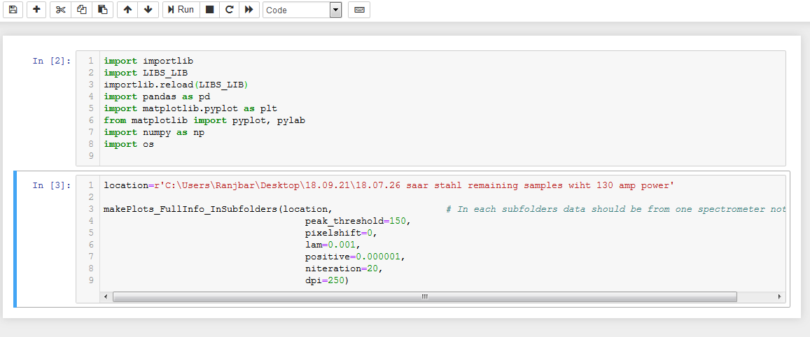

Copy the location of the folder here

6_Run both cells consecutively by pressing Strg(Ctrl)+Enter on each cell.

After execution is finished, in each subfolder two folders are created which include the image plots and CSV files of the calculated information.

# Updating the reference database

The spectra from new materials can be added in the below location to be also taken into comparison while running the above function:

**\\ipmlan\PK\Projekte\Fraunhofer\600610_InlineElement\10_akt_Arbeiten_Mitarbeiter\Alireza\Automatic libs sample analysis with database**

In addition, if a better spectrum for a pure material is available, with less noise or less background, after deleting the old version of that spectrum from the above folder, the new one can be replaced inside it.

# Working principle of the algorithm

Initially, the algorithm removes the background under the spectra of the materials in the database to be able to find the peaks in it.

This is done by the below function **in the source code**:

**Analyse_And_Read_Updated_Database(Avantes=1, peak_threshold=150, lam=0.001, positive=0.000001, niteration=20)**

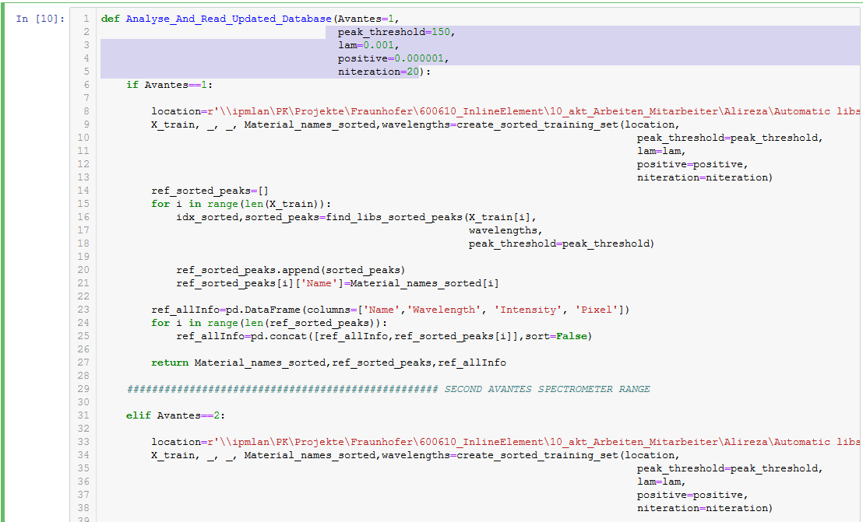

Parameters description are as follows:

**Avantes**: which avantes spectrometer is used. 1 and 2 refer to 270-540nm and 505_740nm spectrometers respectively.

**peak_threshold:** for peaks above this value after the background removal the pixel position of the peak is saved.

**lam:** The bigger this parameter, the more smooth the baseline under the spectrum is assumed.

**Positive:** the degree to which values below the baseline is not allowed.

**niteration**: numbers of iterations needed for convergence of this algorithm.

For more information refer to: <https://zanran_storage.s3.amazonaws.com/www.science.uva.nl/ContentPages/443199618.pdf>

In the output of this function the information about the peaks of the materials in the database such as their pixels, intensities and wavelengths are given.

Afterwards, for the samples also the background is removed with the same parameters as above which are given as an input of the main function:

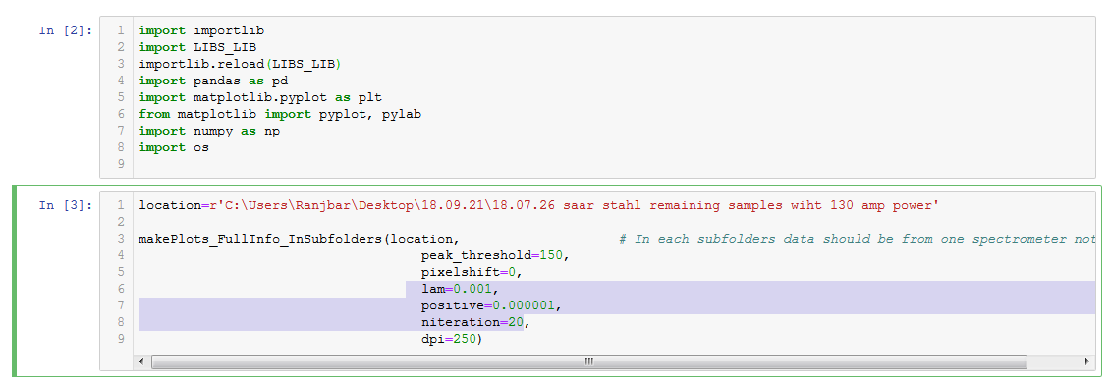

The “**peak_threshold**” parameter here also is the threshold above which peaks will be saved for comparison with the peaks of the database.

If parameter “**pixelshift**” is 1, the algorithm will check if a peak from the sample exists in a material with one pixel right or left. If 0 is given, pixel shift is not allowed.

dpi, is the quality for the plots images which will be saved. Decreasing this value can increase the speed for calculation.

# A fast way to find optimal background removal parameters

One way to play with the parameters regarding the background removal and visually see which ones are better for a special case, is running the following cell which is also in “**LIBS spectra analysis with database.ipynb**” notebook.

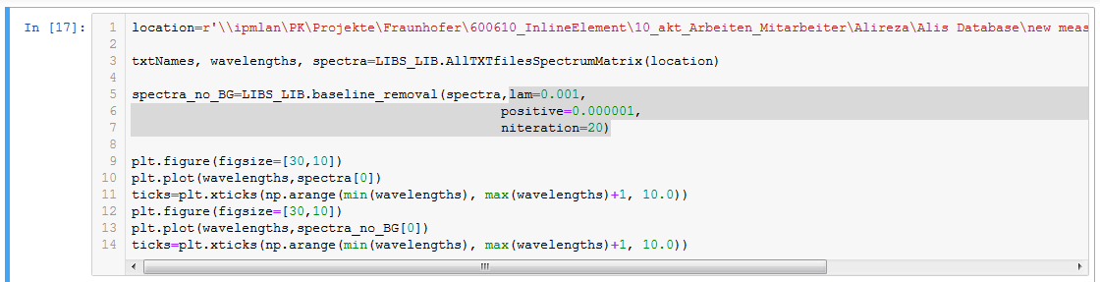

The location of the folder which includes the text file of the spectrum to be played along with baseline parameters should be copied similarly in the “location” in the above code.

# Remarks

This python function is for now only usable for the two Avantes spectrometer and not others.